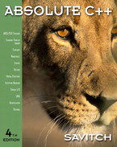 COSC 1320
Name: _________________ Seat # ___

Estimated Hours 5
Actual Hours
Programming Assignment 3 C++:
(100 points)
(Due date found in the COSC 1320 BB Calendar!)
The programming assignment is to be turned in as a hardcopy to include screenshots of the input/output & the source code AND zipped in BB Assignment PROGRAMMING ASSIGNMENT 3 as “Programming Assignment 3.zip” in the first ten minutes of the due date class.
A data file will be given to you in class for Acceptance Testing.
Assume the name “Programming Assignment 3 Data.txt”.

The hardcopy must contain the following statement and must be signed by the student.

I the undersigned, declare that the project material, which I now submit, is my own work. Any assistance received by way of borrowing from the work of others has been cited and acknowledged within the work. I make this declaration in the knowledge that a breach of the rules pertaining to project submission may carry serious consequences.

Signature ____________________________

This is the only page you need to turn in as hardcopy.

